Lab 7: Overview of high availability and disaster recovery

Lab: Planning and implementing a high availability and disaster recovery solution

**Scenario**

Adatum Corporation is looking to assess and configure the new high availability features and technologies that they can leverage. As the system administrator, you have been tasked with performing that assessment and implementation.

Exercise 1: Determining the appropriate high availability and disaster recovery solution

**Scenario**

Adatum Corporation has its headquarters in New York. It is reviewing its current disaster recovery strategy after a recent fire in a remote office in London resulted in the loss of some data. It was also decided to review the current strategies around high availability. Adatum is considering an upgrade to Windows Server 2022 and wants to determine if there are any Windows Server 2022 features that it can leverage. Budgets are also under pressure and management is looking to see if there are any cost savings that can be can realized to help offset the expenditure to replace existing legacy storage currently being used with a Hyper-V cluster. Adatum has the following business requirements:

* Public facing financial transactions take place online.
* There are 1, 000 employees across Application/Product Development, HR, Finance, Customer Service, IT, and Sales.
* Finance cannot tolerate any downtime in their SQL and finance applications, which are running on Hyper-V.
* The finance team requires less than 1 min downtime for their RTO and zero data loss as their RPO on their customer facing transactions.
* The finance division is also growing at a very fast rate, and they expect increased demand for application and services.

**The solution should:**

* Allow for monthly patching with no downtime.
* Allow for existing legacy storage to be replaced without downtime to the Hyper-V cluster.
* Provide a disaster recovery strategy that allows for recovery of critical virtual machines should there be another disaster event in either office location. The main task for this exercise is as follows:
* Design the appropriate high availability and disaster recovery solution

Task 1: Design the appropriate high availability and disaster recovery solution

**Question:** What actions should you take and which technologies should you consider using?

**Answer:**

* Create a Business Recovery Plan to outline and prioritize the divisional and service requirements, with the customer facing financial requirements having the most critical requirements
* Consider using Live Migration for monthly planned downtime to allow for patching of your virtual machines.
* Consider using Storage Migration to migrate the virtual machine storage off the existing server, to upgrade the existing servers' storage, and to migrate back the virtual machine storage to the server without any virtual machine downtime.
* Consider using Hyper-V Recovery Manager solution, integrated with Hyper-V Replica, to provide disaster recovery for critical VMs in the event of a disaster in any of offices.

Exercise 2: Implementing storage migration

**Scenario**

To balance the number of virtual machines running on both the existing hosts and the new hosts, you plan to move a virtual machine between Hyper-V hosts as it is running and without downtime. First, you will configure a destination Hyper-V host to allow live migration. Next, you will use the Move Wizard to move virtual machine storage, its virtual hard disk, and its checkpoints, to the Hyper-V host of your partner.

The main task for this exercise is as follows:

1. Import Virtual Machines
2. Configure and perform storage migration.

Task 0: Configure Hyper-V and Import Virtual Machines

1. Switch to [**LON-HV1**](urn:gd:lg:a:select-vm)
2. Send the [**CTRL+ALT+DEL**](urn:gd:lg:a:send-vm-key-combo) command and login on as **[Adatum\AdatumAdmin](urn:gd:lg:a:send-vm-keys" \o "Paste text into VM)** with the password [**Pa55w.rd**](urn:gd:lg:a:send-vm-keys)

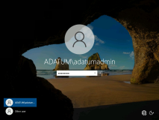

1. Right click the **Start** menu and select **Windows PowerShell (Admin)**.

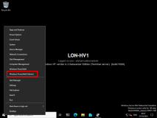

1. Run the following commands to configure the virtual networks and import the virtual machines required for this lab.
2. cd d:
3. .\CreateVirtualSwitches.ps1
4. Import-VM -Path "D:\Export\LON-VM1\Virtual Machines\99730826-D533-4D10-ACD9-494EA10026BA.vmcx"
5. Import-VM -Path "D:\Export\LON-VM2\Virtual Machines\15A845A6-85A6-4DD1-923A-540B45F3AA41.vmcx"

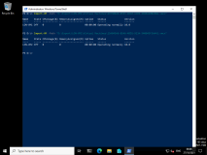

1. Switch to [**LON-HV2**](urn:gd:lg:a:select-vm)
2. Send the [**CTRL+ALT+DEL**](urn:gd:lg:a:send-vm-key-combo) command and login on as **[Adatum\AdatumAdmin](urn:gd:lg:a:send-vm-keys" \o "Paste text into VM)** with the password [**Pa55w.rd**](urn:gd:lg:a:send-vm-keys)



1. Right click the **Start** menu and select **Windows PowerShell (Admin)**.



1. Run the following command to install Hyper-V.

**Note**: Do not wait for the command to finish, you can continue to the next step.

Install-WindowsFeature Hyper-V -IncludeManagementTools -restart

1. Leave the command running and switch to [**LON-HV1**](urn:gd:lg:a:select-vm)

Task 1: Configure and perform storage migration

1. Open Hyper-V manager by clicking the shortcut on the taskbar.

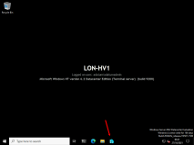

1. In Hyper-V Manager, right-click **LON-VM1**, and then click **Settings**.

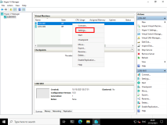

1. In **Settings** for **LON-HV1**, under **IDE Controller 0**, click **Hard Drive**. Confirm that it is using the **LON-VM1.vhd** that is stored locally, and then click **OK**.

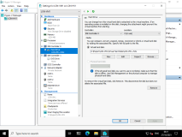

1. In **Hyper-V Manager**, right-click **LON-VM1**, and then click **Move**.

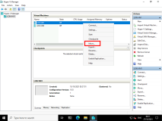

1. In the **Move "LON-VM1" Wizard**, on the **Before You Begin** page, click **Next**.

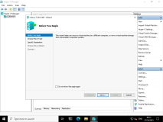

1. On the **Choose Move Type** page, select the **Move the virtual machine's storage** option, and then click **Next**.

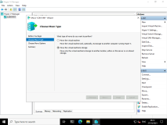

1. On the **Choose Options for Moving Storage** page, select the **Move only the virtual machine's virtual hard disks** option, and then click **Next**.

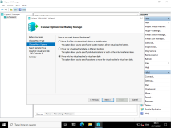

1. On the **Select Items to Move** page, confirm that the **LON-VM1.vhdx** is selected, and then click **Next**.

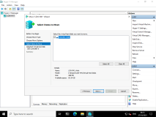

1. On the **Choose a new location for attached virtual hard disk** page, in the **Folder** text box, type [**C:\VMs\LON-VM1**](urn:gd:lg:a:send-vm-keys), and then click **Next**.

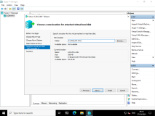

1. On the **Completing Move Wizard** page, click **Finish**.

**Note:** Because the VHD is dynamically expanding and is small, the move occurs quickly.

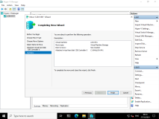

1. In Hyper-V Manager, right-click **LON-VM1**, and then click **Settings**.

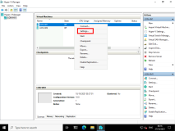

1. In **Settings** for **LON-VM1**, under **IDE Controller 0**, click **Hard Drive**. Confirm that **LON-VM1.vhdx** is stored on **C:\VMs** folder structure.

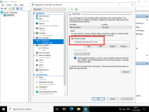

**Results** : After completing this exercise, you should have moved Hyper-V storage and virtual machines.

Exercise 3: Configuring Hyper-V Replicas

**Scenario**

Before you start with a cluster deployment, you have decided to evaluate the new technology in Hyper-V for replicating virtual machines between hosts. You want to be able to mount a copy of a virtual machine on to another host manually if the active copy or host fails.

The main tasks for this exercise are as follows:

1. Configure a replica on both host machines.
2. Configure replication for LON-VM1 virtual machine.
3. Validate a planned failover to the replica site.
4. Prepare for the next module.

Task 1: Configure a replica on both host machines

1. In the **Hyper-V Manager** console, right click **LON-VM1** and select start.

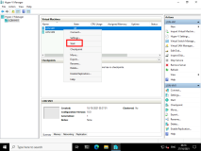

1. In Hyper-V Manager, right-click **LON-HV1**, and then select **Hyper-V Settings**.

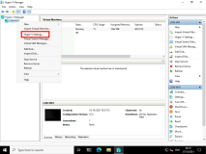

1. In **Hyper-V Settings for LON-HV1**, click **Replication Configuration**.

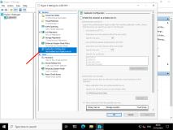

1. In the **Replication Configuration** pane, click **Enable this computer as a Replica server**.

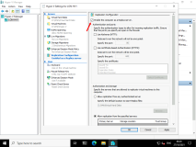

1. In the **Authentication and ports** section, select **Use Kerberos (HTTP)**.

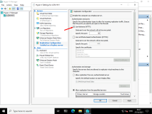

1. In the **Authorization and storage** section, click **Allow replication from any authenticated server**, and then click **Browse**.

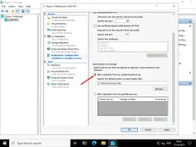

1. Expand **This PC**, double-click **Local Disk (D)**, and then click **New folder**. For the folder name, type **[VMReplica](urn:gd:lg:a:send-vm-keys" \o "Paste text into VM)**, and then press Enter. Select the **D:\VMReplica\** folder, and then click **Select Folder**.

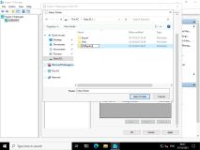

1. In **Hyper-V Settings for LON-HV1**, click **OK**.

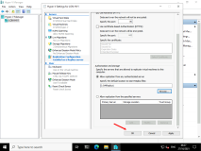

1. In the **Settings** dialog box, read the notice, and then click **OK**.

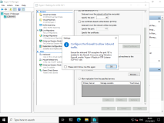

1. Click **Start**, and then search for [**Firewall**](urn:gd:lg:a:send-vm-keys)

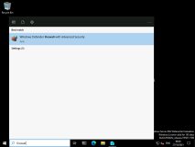

1. Select **Windows Defender Firewall with Advanced Security**.

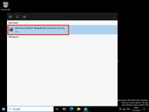

1. Click **Inbound Rules**.

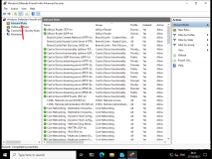

1. In the right pane, in the rule list, find and right-click the **Hyper-V Replica HTTP Listener (TCP-In)** rule, and then click **Enable Rule**.

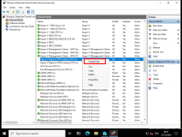

1. Close the **Windows Firewall with Advanced Security** console, and then close the **Windows Firewall**.
2. Switch to [**LON-HV2**](urn:gd:lg:a:select-vm) and enter the [**CTRL+ALT+DEL**](urn:gd:lg:a:send-vm-key-combo) command and login on as **[Adatum\AdatumAdmin](urn:gd:lg:a:send-vm-keys" \o "Paste text into VM)** with the password [**Pa55w.rd**](urn:gd:lg:a:send-vm-keys)
3. Click **Start** and select **Server Manager**.

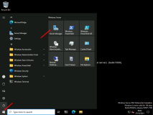

1. Select **Tools** and then select **Hyper-V Manager**
2. In Hyper-V Manager, right-click **LON-HV2**, and then select **Hyper-V Settings**.

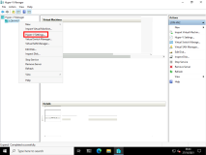

1. In **Hyper-V Settings for LON-HV2**, click **Replication Configuration**.

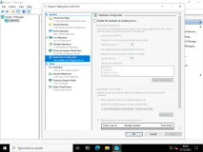

1. In the **Replication Configuration** pane, click **Enable this computer as a Replica server**.

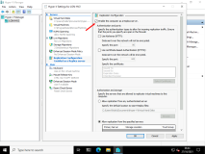

1. In the **Authentication and ports** section, select **Use Kerberos (HTTP)**.

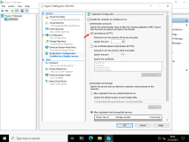

1. In the **Authorization and storage** section, click **Allow replication from any authenticated server**, and then click **Browse**.



1. Expand **This PC**, double-click **Local Disk (D)**,and then click **New folder**. For the folder name, type **[VMReplica](urn:gd:lg:a:send-vm-keys" \o "Paste text into VM)**, and then press Enter. Select the **D:\VMReplica\** folder, and then click **Select Folder**.

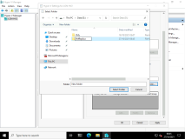

1. In **Hyper-V Settings for LON-HV2**, click **OK**.

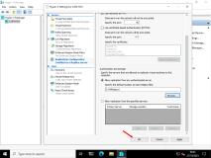

1. In the **Settings** dialog box, read the notice, and then click **OK**.

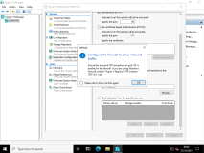

1. Click **Start**, and then search for [**Firewall**](urn:gd:lg:a:send-vm-keys)
2. Select **Windows Defender Firewall with Advanced Security**.

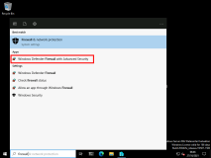

1. Click **Inbound Rules**.



1. In the right pane, in the rule list, find and right-click the **Hyper-V Replica HTTP Listener (TCP-In)** rule, and then click **Enable Rule**.



1. Close the **Windows Firewall with Advanced Security** console, and then close the **Windows Firewall**.

Task 2: Configure replication for the LON-VM1 virtual machine

1. Switch to [**LON-HV1**](urn:gd:lg:a:select-vm)
2. On **LON-HV1**, open the **Hyper-V Manager** console. Right-click **LON-VM1** and click **Enable Replication**.

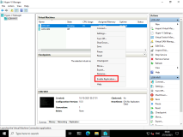

1. On the **Before You Begin** page, click **Next**.

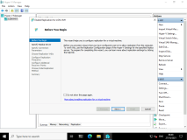

1. In the **Replica Server** box, type [**LON-HV2**](urn:gd:lg:a:send-vm-keys) and then click **Next**.

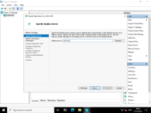

1. On the **Specify Connection Parameters** page, ensure **Use Kerberos authentication (HTTP)** is selected and then click **Next**.

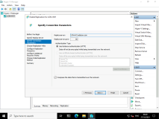

1. On the **Choose Replication VHDs** page, click **Next**.

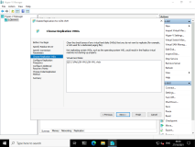

1. On the **Configure Replication Frequency** page, from drop-down list box, select **30 seconds**, and then click **Next**.

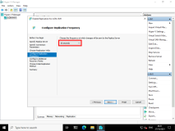

1. On the **Configure Additional Recovery Points** page, select **Maintain only the latest recovery point**, and then click **Next**.

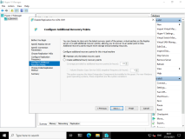

1. On the **Choose Initial Replication Method** page, click **Send initial copy over the network**, select **Start replication immediately**, and then click **Next**.

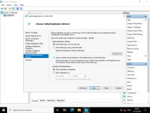

1. On the **Completing the Enable Replication Wizard** page, click **Finish**.

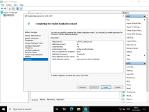

1. At the **Replication enabled successfully** prompt, click **Close**.

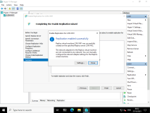

1. Wait one minute. You may not be able to monitor the progress of the initial replication due to the VM being very small in size, instead, ensure that **LON-VM1** has appeared on [**LON-HV2**](urn:gd:lg:a:select-vm) in **Hyper-V Manager**.

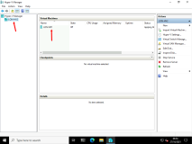

Task 3: Validate a planned failover to the replica site

1. On [**LON-HV1**](urn:gd:lg:a:select-vm), in Hyper-V Manager, right-click **LON-VM1** and select **Replication**, and then click **View Replication Health**.

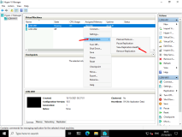

1. Review content of the window that appears, and ensure that there are no errors.

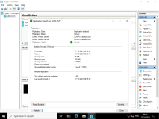

1. Click **Close**.
2. Switch to [**LON-HV2**](urn:gd:lg:a:select-vm), in **Hyper-V Manager**, note **LON-VM1** is turned off.

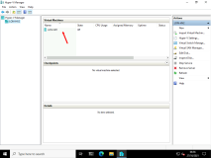

1. Switch back to [**LON-HV1**](urn:gd:lg:a:select-vm), in **Hyper-V Manager**, note **LON-VM1** is running.

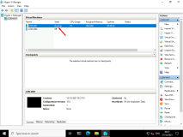

1. Right click **LON-VM1** and select **Shut down**.

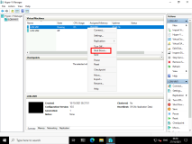

1. On [**LON-HV1**](urn:gd:lg:a:select-vm), in Hyper-V Manager, right-click **LON-VM1**, point to **Replication,** and then click **Planned Failover**.

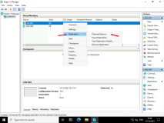

1. In the **Planned Failover** window, ensure that the option **Start the Replica virtual machine after failover** is selected, and then click **Fail Over**.

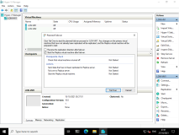

1. Switch to [**LON-HV2**](urn:gd:lg:a:select-vm), in **Hyper-V Manager**, ensure that **LON-VM1** is running.

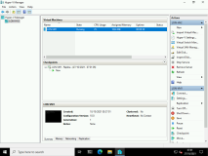

**Results**: After completing this exercise, you will have configured Hyper-V Replica.

**Congratulations!** You have now completed this lab. To continue to the next lab click End Lab in the Tools Menu . If you wish to contiue with this lab at a later date ensure you save the lab environment rather than ending it.